**Practicals**

Step 1: Open Application -> Visual Studio 2019 -> Create Project -> Analysis services multidimensional and data mining project -> Create

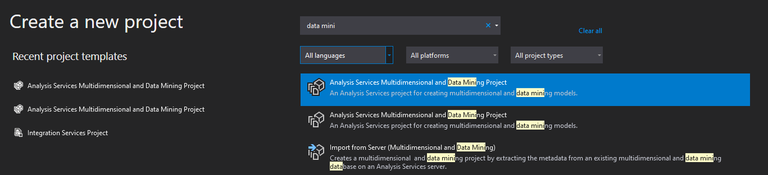

Step 2: Right Click on Data Sources -> New Data Source

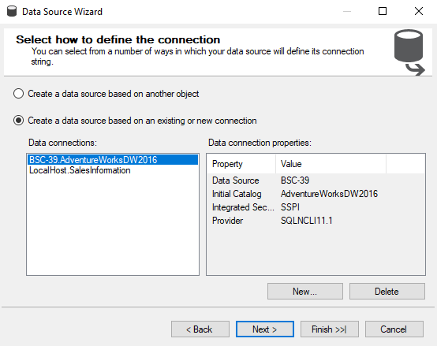

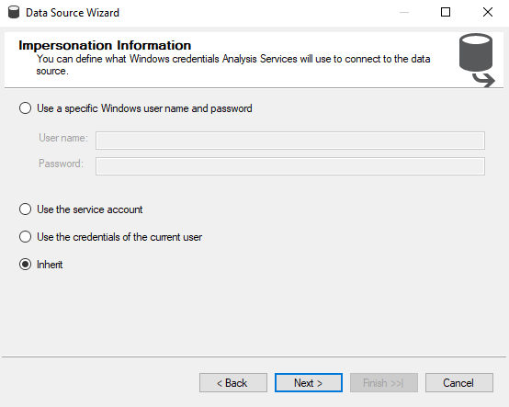

Step 3: Click on Next . Choose “Inherit” option.

Step 4: Right click on Data Source View -> New Data Source View

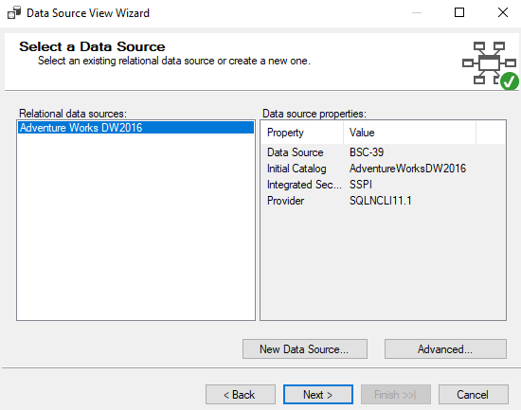

Step 5: Click on Next -> Use filter “Product”. Select Tables and Views. ->

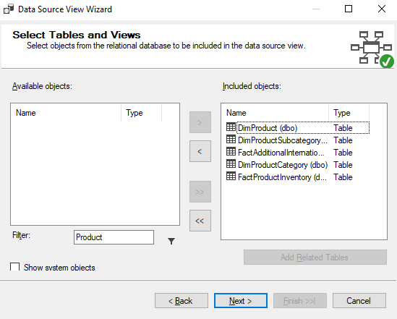

Step 6: Next & Finish Finally, we will get the Data Source View like

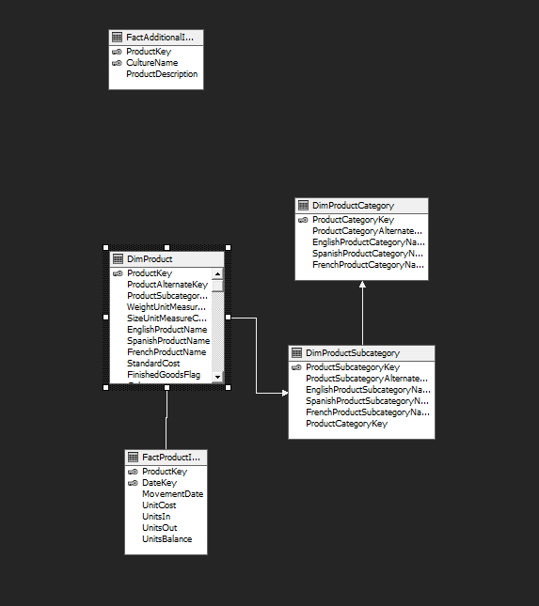

Step 7: Right click on Cubes -> New Cube.

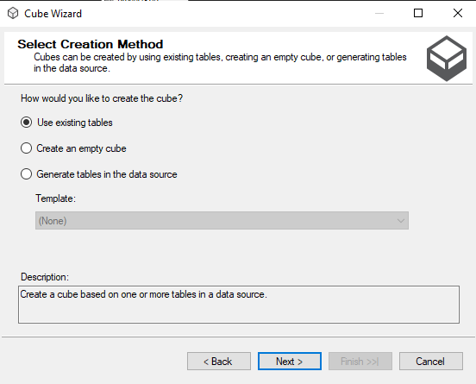

Step 8: Click Next

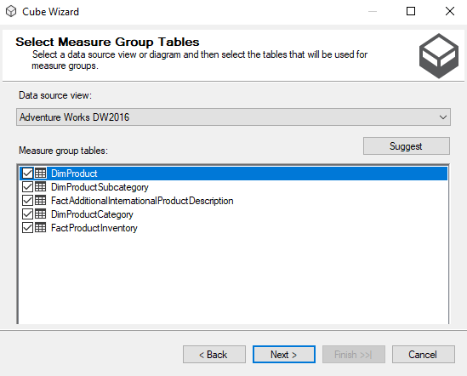

Step 9: Select Data Source View as “Sales Product” and Select all the tables.

Step 10: Next > Next > Name the Cube > Finish

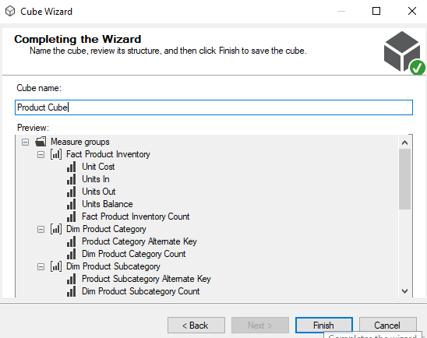

Step 11: Finally, we will get the Cube View as well Dimensions View like :

c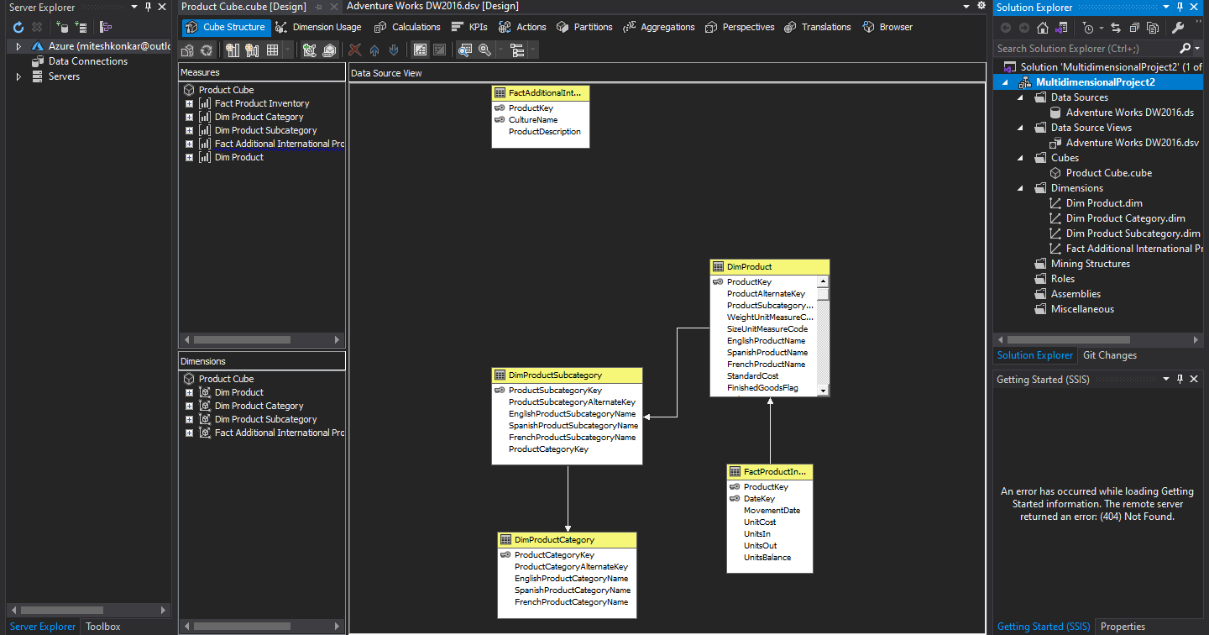

Step 12: Finally, Process cube by Right click on ProductCube -> Process .

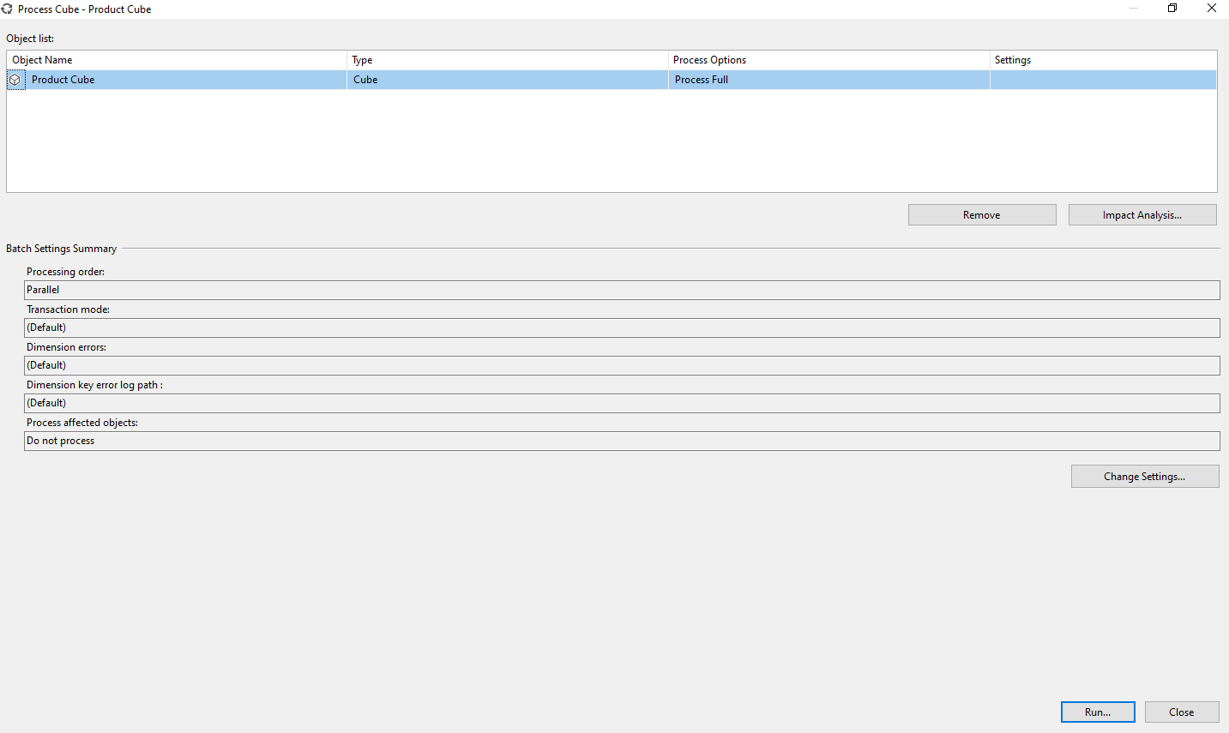

Step 13: Click on Run.

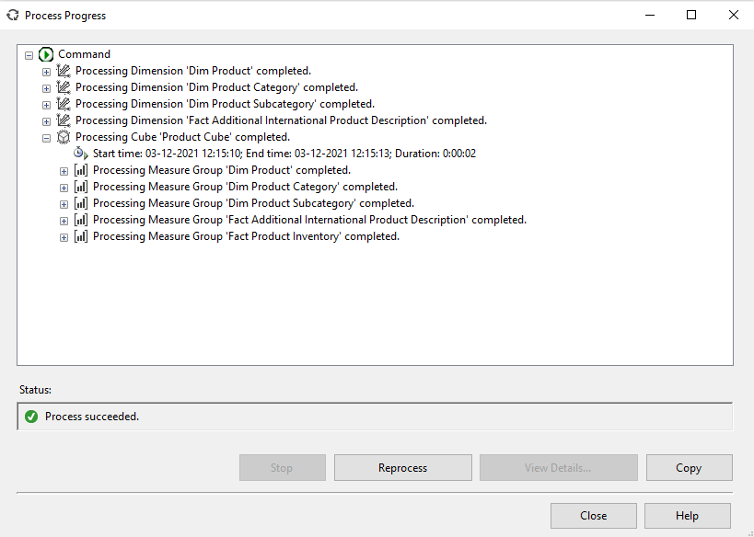

Step 14: Open MS-Excel. Click on Data Menu.

Step 15: Go to From Other Sources.

Step 16: From SQL Server -> Type Server name as “.”

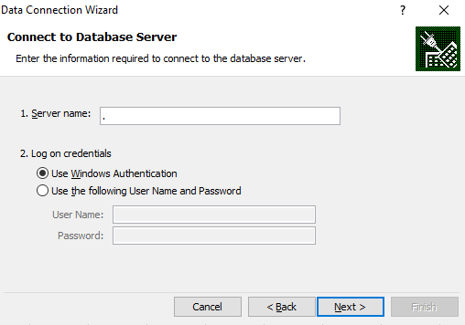

Step 17: Click on Next. Choose SQL Database ->

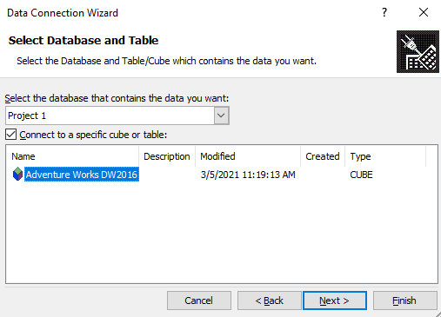

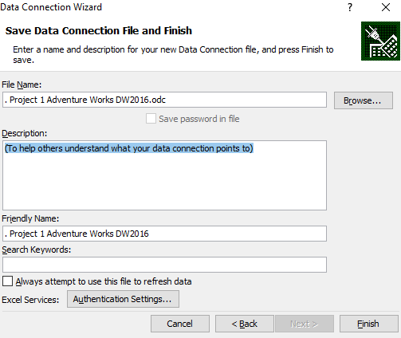

Step 18: Click on Finish

Step 19: Select Result Area. Go to Insert Menu. Select Pie Chart option.

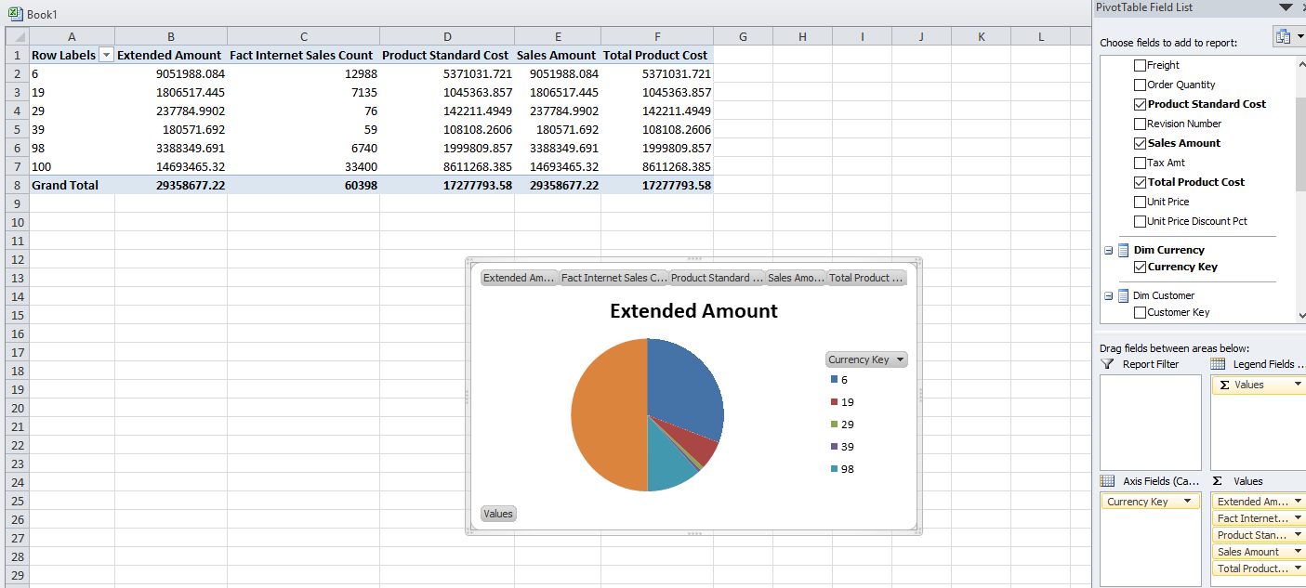

Step 20: Select Result Area. Go to Insert Menu. Select Column option.

